 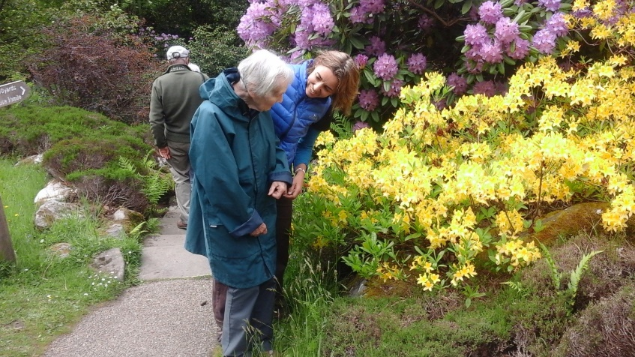

**Volunteers needed for - Well-being outdoor strolls**

* Are you interested in community projects?
* Do you like sharing time and nature outdoors?
* Do you feel able to support a person within a group on a short outdoor walk?

**We are looking for volunteers to assist or lead sensory strolls for adults.**

**What does the role involve?**

Supporting people living with dementia and family carers to enjoy a short sensory stroll in a local park or open space on a regular basis. Walks are full of stops and starts, can be social or quiet and make the most of what a park has to offer. Supported walks have proven health and wellbeing benefits especially for people living with dementia and their carers.

**Training:** Volunteers receive a full day’s training and information pack carried out by Dementia Adventure. They will learn new skills about engaging & supporting people with dementia and family carers to get the most out of time outside.

**Volunteers should be able to:**

* Offer 1.5 - 2 hours weekly, or every 2-3 weeks
* Be part of a team of walk assistant/leaders
* Take part in a stroll that typically lasts 45-mins - 1 hour
* Be available midweek for mid-morning or afternoon stroll
* Be happy to be part of a group
* Need to make own way to meeting point
* Have the following essential skills: Friendly, enjoy outdoors, patience and listening skills, flexibility
* Walk leading experience is not a requirement but can be helpful
* There is no fitness requirement

**The Walks -**

* First strolls are led by staff and then support is provided by a lead volunteer
* Regular support and supervision is offered by the Volunteer Coordinator
* Strolls are risk assessed and covered by 3rd party liability insurance

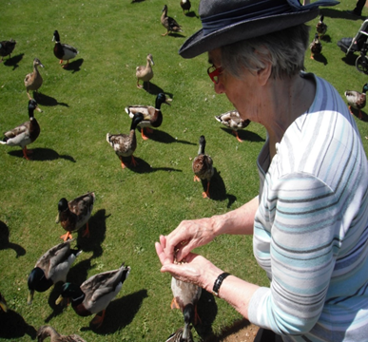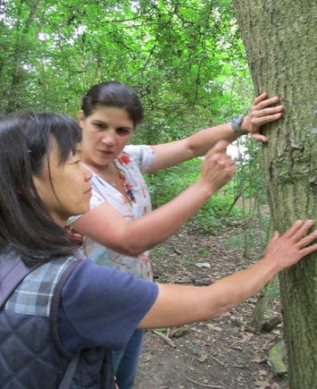

**What do volunteers gain from the role?**

* New skills to support and engage with people living with dementia and family carers on short outdoor strolls
* Learn to plan walks for sensory enjoyment and interaction
* Satisfaction from being part of a team providing a unique friendly and welcoming well-being activity in your area
* The skills to assist you in becoming a walk leader with ongoing expert support
* Regular gentle activity for yourself
* An opportunity to meet new friends, do something worthwhile and have fun!

**If you are interested please contact:**

|  |  |
| --- | --- |
| TRACEY WILKINSON  LIFESTYLE PARTNERSHIPS LEAD  Magna Vitae Trust for Leisure & Culture  Office: 01507 613461  Mobile: 07500 020 193 |  |